**AWS Container Immersion Day: Lab 2**

Lab 2 will build on Lab 1.

## 9. Creating the ALB

Now that we've pushed our images, we need an Application Load Balancer ([ALB](https://aws.amazon.com/elasticloadbalancing/applicationloadbalancer/)) to route traffic to our endpoints. An ALB lets you direct traffic between different endpoints and in this lab, we'll use two separate endpoints: /web and /api.

To create the ALB, navigate to the [EC2 Console](https://console.aws.amazon.com/ec2/), and select **Load Balancers** from the left-hand menu. Choose **Create Load Balancer**:

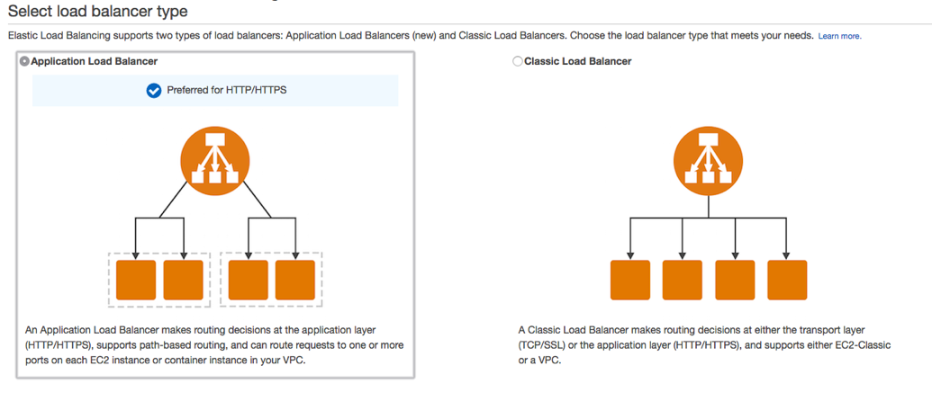

Select Application Load Balancer, name your ALB **EcsLabAlb** and add an HTTP listener on port 80:

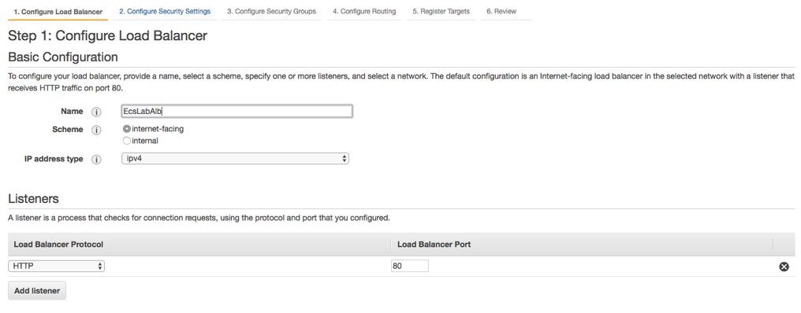

Note: in a production environment, you should also have a secure listener on port 443. This will require an SSL certificate, which can be obtained from [AWS Certificate Manager](https://aws.amazon.com/certificate-manager/), or from your registrar/CA. For the purposes of this lab, we will only create the insecure HTTP listener. DO NOT RUN THIS IN PRODUCTION.

Next, select your VPC and we need at least two subnets for high availability. Make sure to choose the VPC that we created earlier.

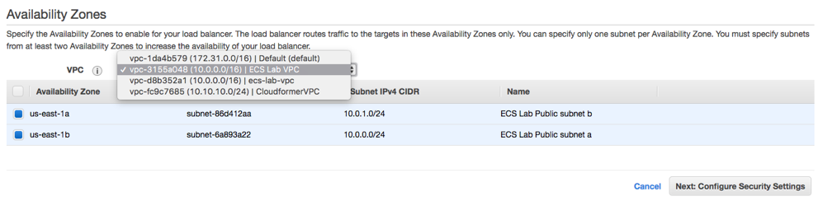

Next, create a new security group (EcsLabLoadBalancerSg) with the following rule:

Ports Protocol Source

80 tcp 0.0.0.0/0

Choose the security group, and continue to the next step: adding routing. For this initial setup, we're just adding a dummy health check on /. We'll add specific health checks for our service endpoints when we register them with the ALB.

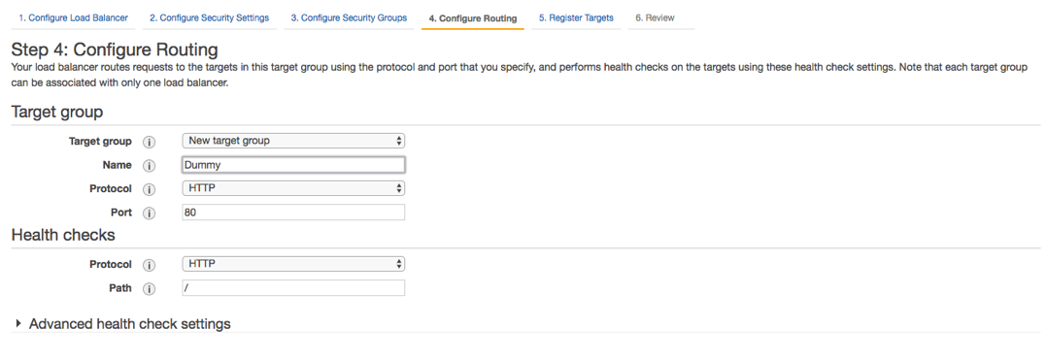

Skip the "Register targets" step, and continue to review. If your values look correct, click **Create**.

You created an empty security group for the ECS Cluster (EcsLabPublicClusterSg) in lab 1.

Now you need to add a rule allowing traffic from your load balancer to communicate with your ECS cluster.

Open the EC2 console and Edit inbound rules for your EcsLabPublicClusterSg security group; add a rule to allow your ALB security group (EcsLabLoadBalancerSg) to access the port range for ECS (0-65535) for port mapping. This rule references itself and you will see the security group appears when you start typing “sg-” in the **Source** textbox for the **All TCP** rule.

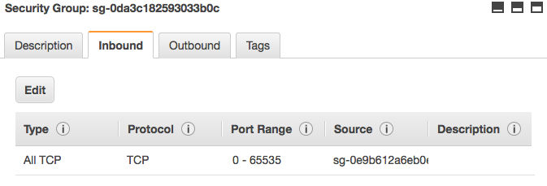

We now have the following security group setup:

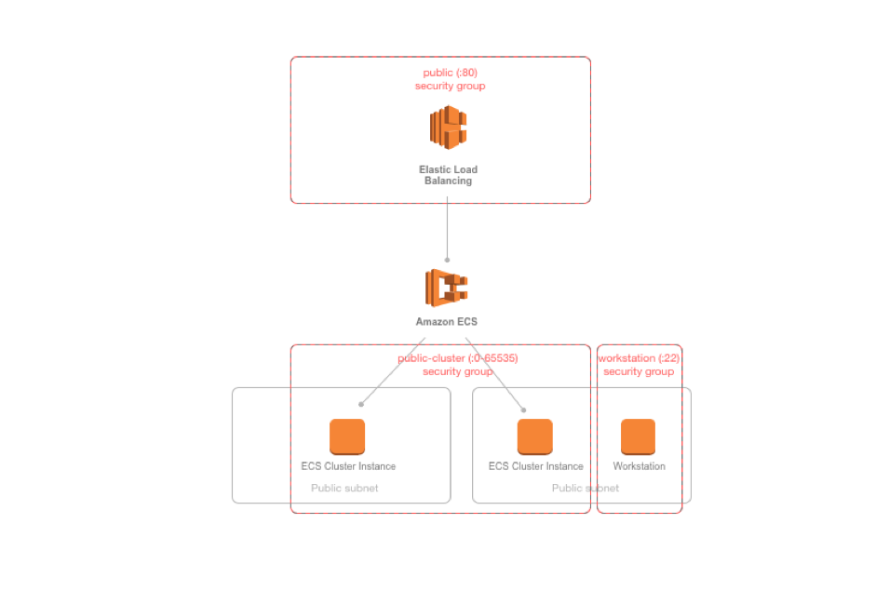

## 10. Creating the Task Definitions

We need to create a service in ECS but before that can be done, the container needs be a part of a [Task Definition](https://docs.aws.amazon.com/AmazonECS/latest/developerguide/create-task-definition.html). Task Definitions define things like environment variables, the container image you wish to use, and the resources you want to allocate to the service (port, memory, CPU). To create a Task Definition, choose **Task Definitions** from the ECS console menu. Then, choose **Create new Task Definition**:

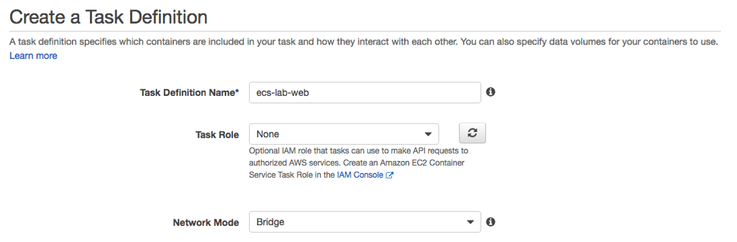

Next, click on **Add Container**. 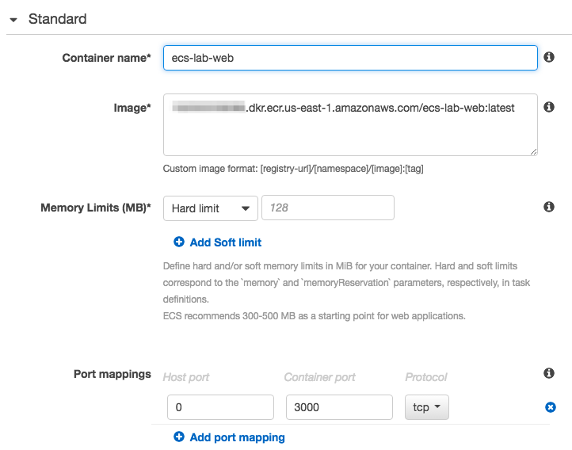

A few things to note here:

* We've specified a specific container image, including the :latest tag. Although it's not important for this lab, in a production environment where you were creating Task Definitions programmatically from a CI/CD pipeline, Task Definitions could include a specific SHA hash, or a more accurate tag.
* We’ve set the memory hard limit to **128**
* Under **Port Mappings**, we've specified a **Container Port** (3000), but left **Host Port** as 0. This is required to facilitate dynamic port allocation. This means that we don't need to map the Container Port to a specific Host Port in our Container Definition; instead, we can let the ALB allocate a port during task placement. To learn more about port allocation, check out the [ECS documentation here](http://docs.aws.amazon.com/AmazonECS/latest/APIReference/API_PortMapping.html).

Once you've specified your Port Mappings, scroll down and add a log driver. There are a few options here, but for this lab, choose **awslogs**:

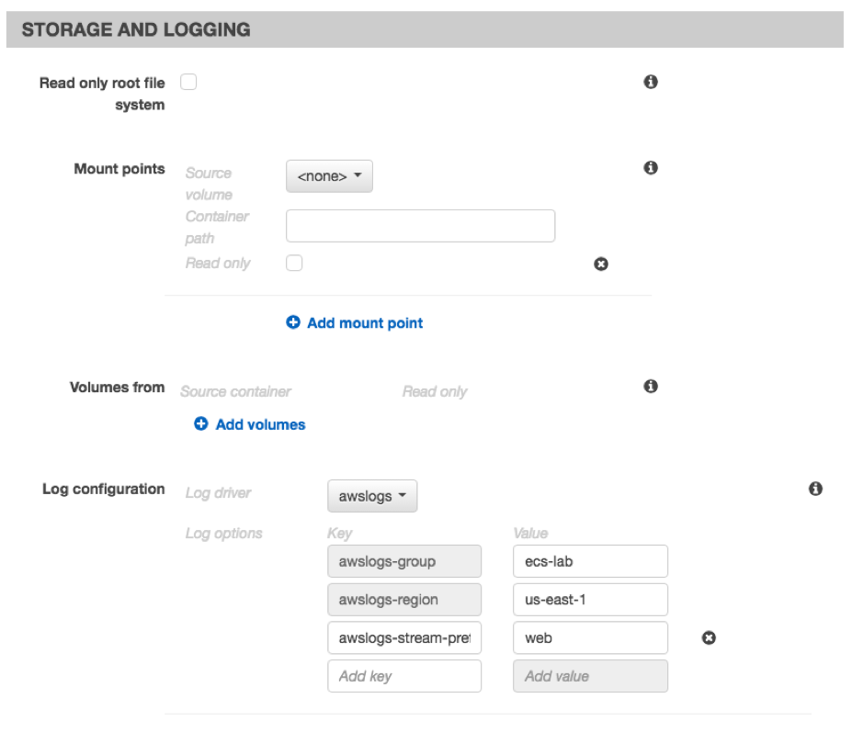

us-east-2

*Be sure to enter the Region you’re utilizing throughout these labs*

For this web container, make sure the **awslogs-stream-prefix** is **web**. Once you've added your log driver, save the Container Definition by clicking **Add**, and click on **Create** to complete the Task Definition.

Repeat the Task Definition creation process with the API container, taking care to use the api container image registry, and the correct port (8000) for the **Container Port** option. For the log driver, make sure the **awslogs-stream-prefix** is **api**.

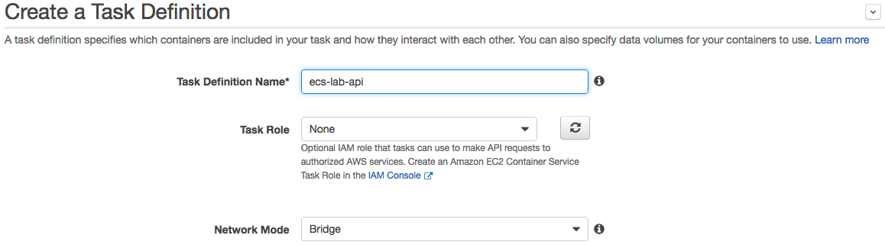

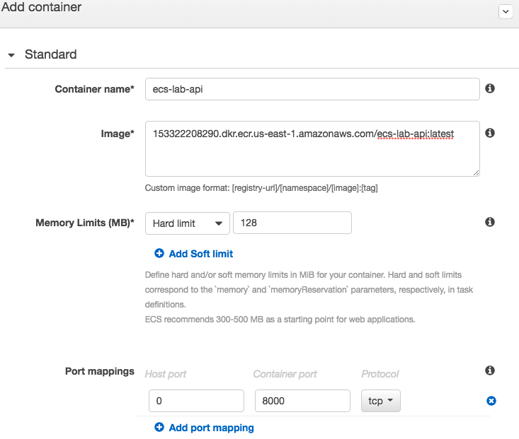

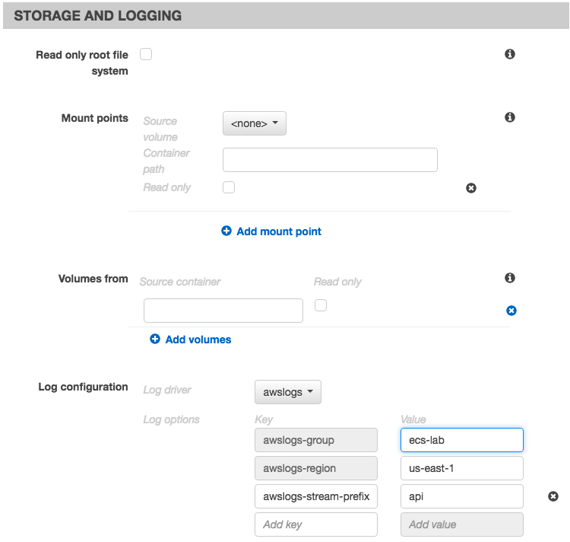

Don’t forget to click on **Create** to complete the Task Definition.

Next, create the log group by navigating to the [CloudWatch](https://console.aws.amazon.com/cloudwatch) **> Logs > Actions > Create Log Group**

| **Field** | **Value** |
| --- | --- |
| Log Group Name | ecs-lab |

## 11. Creating the Services

Next, we're going to create the service based on our Task Definition. A service is a group of tasks (which are containers). You can define how many tasks you want to run simultaneously, specify load balancing, auto scaling and configure many other options.

First, we need to create a IAM role for this Service. Navigate to [IAM](https://console.aws.amazon.com/iam/) > Roles > Create role. Select Elastic Container Service for the service that will use the role and Elastic Container Service as your use case. Attach the default policy (AmazonEC2ContainerServiceRole) and name it EcsLabServiceProfile

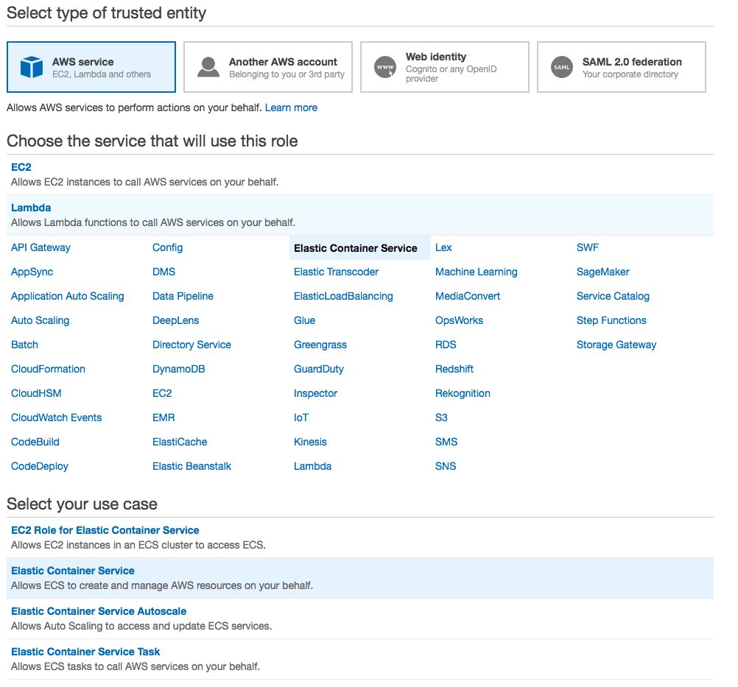

Navigate back to the ECS console, and choose the cluster that you created. This should be named **EcsLabPublicCluster**. From the cluster detail page, choose **Services** > **Create**.

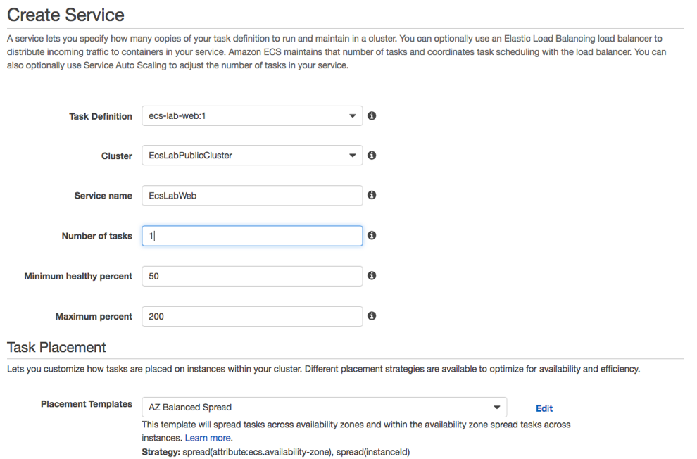

Choose the web Task Definition you created in the previous section. For the purposes of this lab, we'll only start one copy of each task. In a production environment, you will always want more than one copy of each task running for reliability and availability.

You can keep the default **AZ Balanced Spread** for the Task Placement Policy. To learn more about the different Task Placement Policies, see the [documentation](http://docs.aws.amazon.com/AmazonECS/latest/developerguide/task-placement-strategies.html), or this [blog post](https://aws.amazon.com/blogs/compute/introducing-amazon-ecs-task-placement-policies/).

Under **Load balancing**, configure your ALB:

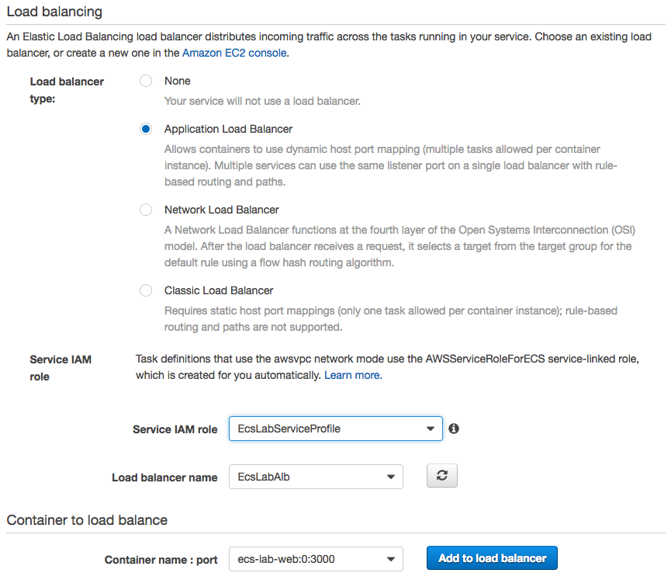

Select the web container, choose **Add to load balancer**.

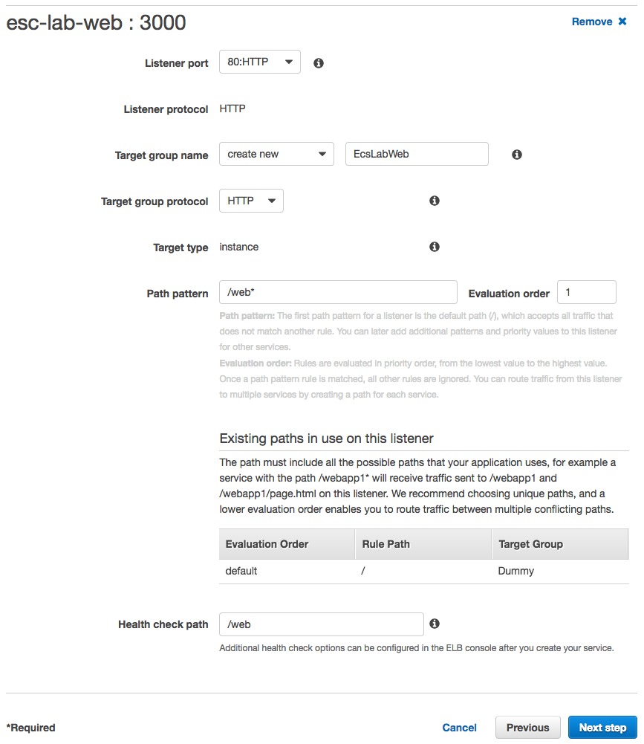

This final step allows you to configure the container with the ALB. When we created our ALB, we added a listener for HTTP:80. Select this from the dropdown as the value for **Listener**. For **Target Group Name**, enter a value that will make sense to you later, like **EcsLabWeb**. For **Path Pattern**, the value should be **/web\***. This is the route that we specified in our Python application. Finally, make sure the **Health check path** is set to **/web**.

If the values look correct, click **Next step** twice. Then review your configuration and click **Create Service.**

Repeat this process for the api microservice and task definition. Don't forget to adjust the target group name, path pattern, evaluation order and health check path accordingly.

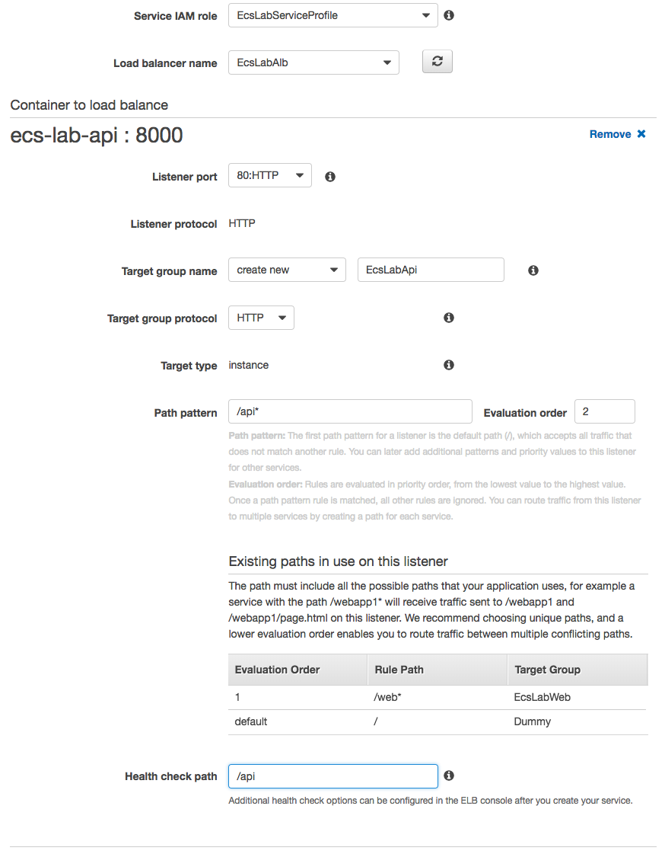

## 12. Testing our service deployments from the console and the ALB

You can see service level events from the ECS console. This includes deployment events. You can test that both of your services are deployed and registered properly with the ALB by looking at the service's **Events** tab:

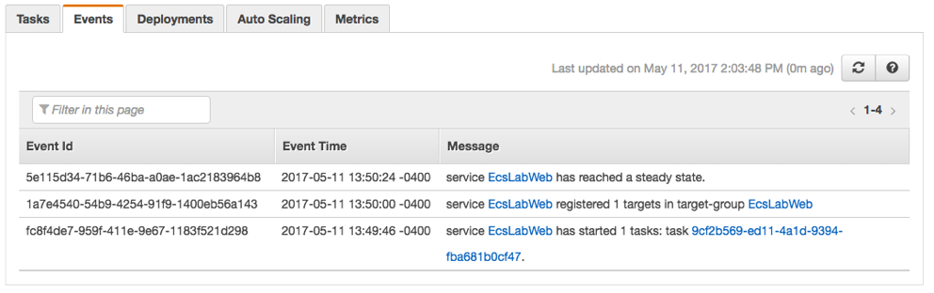

We can also test from the ALB itself. To find the DNS A record for your ALB, navigate to the EC2 Console > **Load Balancers** > **Select your Load Balancer**. Under **Description**, you can find details about your ALB, including a section for **DNS Name**. You can enter this value in your browser, and append the endpoint of your service, to see your ALB and ECS Cluster in action:

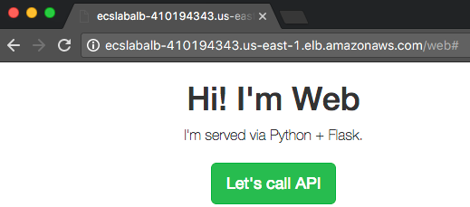

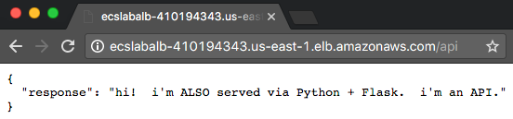

The ALB routes traffic appropriately based on the paths we specified when we registered the containers: /web* requests go to our web service, and /api* requests go to our API service.

## 13. More in-depth logging with Cloudwatch

When we created our Container Definitions, we also added the awslogs driver, which sends logs to [Cloudwatch](https://aws.amazon.com/cloudwatch/). You can see more details logs for your services by going to the Cloudwatch console, and selecting first our log group ecs-lab and then choosing an individual stream:

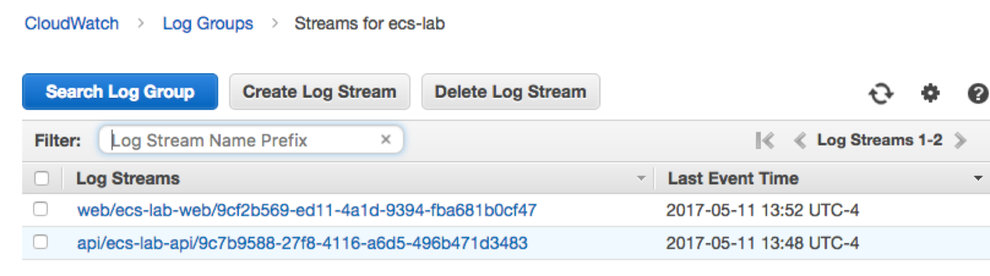

## That's a wrap!

Congratulations! You've deployed an ECS Cluster with two working endpoints.

## Clean up

Don't forget to do the following, after you're finished with the lab:

* Go to **ECS Console** and delete the cluster and the 2 ECR repositories
* Go to the **EC2 Console**, terminate the EcsLabWorkstation EC2 Instance, the Application Load Balancer and the 3 Target Groups, the 3 lab security groups.
* Go to **IAM console** and delete the 3 roles EcslabInstanceProfile, EcsLabWorkstationProfile, and EcslabServiceProfile
* Go to **Cloudwatch Console > Logs** and delete Log Group ecs-lab
* Go to the VPC console and delete the **ECS Lab VPC**